NIELIT, Chandigarh
(In association with IIT Ropar)

PROJECT REPORT
on

Tri-Netra AI
Advanced Brain Tumor Detection & Analysis

Submitted in partial fulfillment of the requirements
for the award of
Post Graduate Diploma in Artificial Intelligence & Machine Learning

Student Name | Anannya Vyas
Roll Number | 9
Enrollment No. | IND/202512/AIM/000014
Branch / Stream | Diploma in Computer Science & Engineering
Academic Year | 2025–26
Industry Mentor | Mr. Sarwan Singh
College Guide | Mr. Munish Bansal

Chandigarh College of Engineering and Technology (Diploma Wing)
Sector 26, Chandigarh – 160 019

CERTIFICATE

This is to certify that the project report entitled "Tri-Netra AI" is a bonafide record of the project work carried out by Anannya Vyas, Roll No. 9, student of Diploma in Computer Science & Engineering, Final Semester, Chandigarh College of Engineering and Technology (Diploma Wing), during the Industrial Training at NIELIT, Chandigarh (in association with IIT Ropar) for the academic year 2025–26.

ABSTRACT

Tri-Netra AI is an advanced, automated framework for binary brain tumor classification and segmentation from MRI images. The system processes an MRI input and routes it through a robust pipeline. First, images are normalized and resized for respective models. Second, Cascade Segmentation using an Attention U-Net (v8) extracts the tumor pixel mask. Third, a 3-classifier ensemble comprising a custom CNN, a Transfer Learning ResNet model, and a highly accurate Vision Transformer (ViT) processes the scan. A consensus rule requires at least 2 of 4 detectors to agree for a final verdict. Following detection, deterministic Feature Extraction computes geometry, intensity, texture, morphology, and mass effect. Finally, a Layered LLM Report validates every clinical claim against measured features, guaranteeing zero hallucinations. Tri-Netra AI achieves 98.25% accuracy, bridging the gap between deep learning research and practical clinical decision support.

TABLE OF CONTENTS

1. Introduction to Company ... 4
2. Introduction to AIML Course ... 5
3. Basics of Python & Data Science ... 6
4. Machine Learning & Deep Learning Fundamentals ... 7
5. Project: Tri-Netra AI ... 9
5.1 Introduction ... 9
5.2 Methodology & Architecture ... 10
5.3 Models & Tech Stack ... 11
5.4 Results & Conclusion ... 12

Chapter 1: Introduction to Company
National Institute of Electronics & Information Technology (NIELIT) is an autonomous scientific society under the Ministry of Electronics & Information Technology, Government of India. It carries out Human Resource Development in IECT.

Chapter 2-4: Training Summary
During the six-month industrial training, the curriculum covered Python, NumPy, Pandas, Matplotlib, HTML/CSS, Machine Learning algorithms, and Deep Learning (CNNs, Transformers, OpenCV). This provided the technical foundation necessary to develop Tri-Netra AI.

Chapter 5: Project - Tri-Netra AI

5.1 Introduction
Tri-Netra AI is an automated deep learning framework for brain tumor classification and analysis from MRI images. Manual interpretation of MRI scans is time-consuming and error-prone. Tri-Netra AI automates this using a robust pipeline of segmentation, an ensemble of classifiers, and a zero-hallucination LLM reporting module.
5.2 Methodology & Architecture
The system follows a strict 6-step architecture as outlined below:
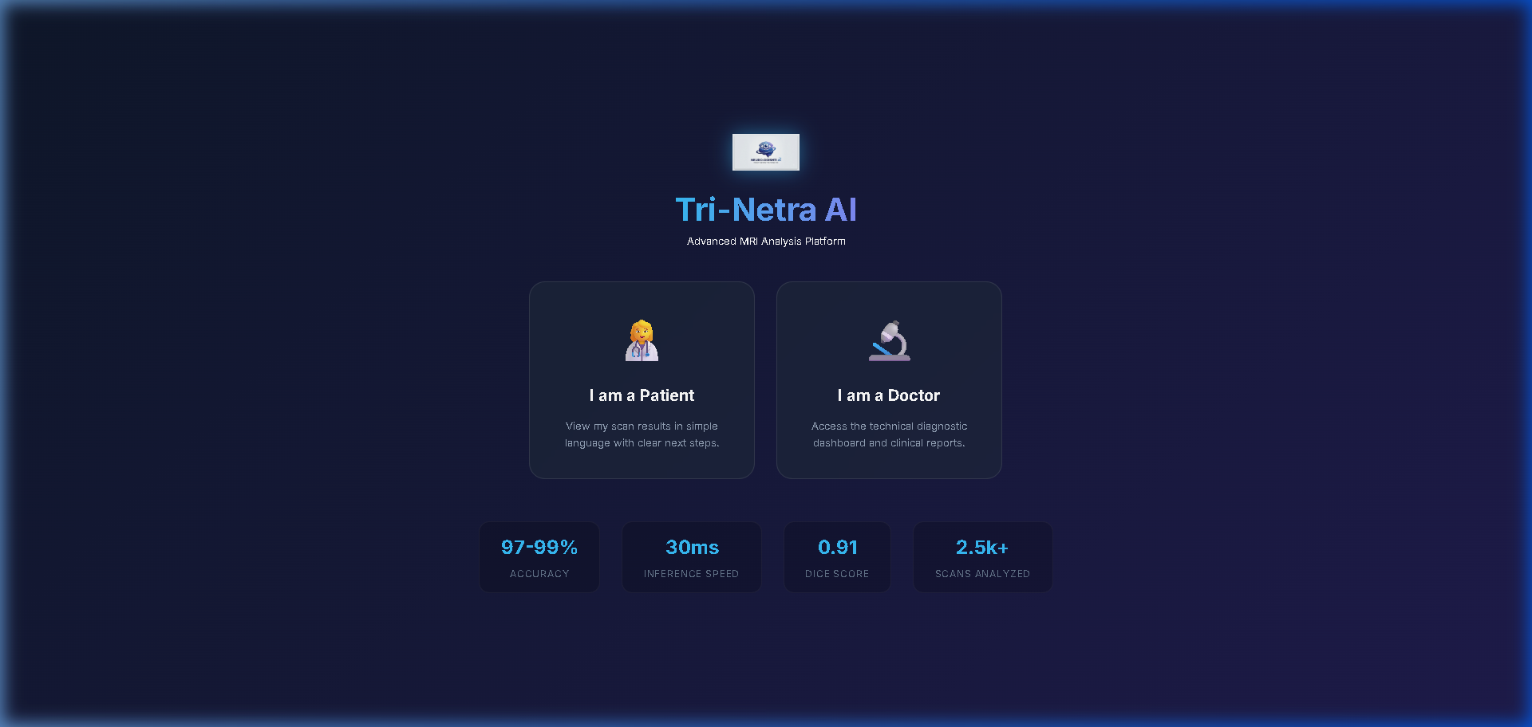
Figure 1: Tri-Netra AI System Architecture

Step 1: Upload and Normalize - MRI input (PNG/JPG/DICOM) is resized to 256x256 for segmentation and 224x224 for classifiers.
Step 2: Cascade Segmentation - An Attention U-Net (v8) creates a pixel mask of the tumor using skip connections.
Step 3: 3-Classifier Ensemble - Consists of a fast CNN (85-90%), a Transfer ResNet (89-93%), and a highly accurate ViT (95-98%). An ensemble rule requires >=2 of 4 detectors to agree.
Step 4: Feature Extraction - Computes deterministic features: Geometry, Intensity, GLCM texture, Morphology, Mass effect, Internal architecture, and Grade evidence score.
Step 5: Conformal Prediction - Guarantees 90% coverage with alpha=0.10.
Step 6: Layered LLM Report - Pattern A (polish), Pattern B (differential), Pattern C (observer). Every claim is validated against measured features for zero hallucination.
5.3 Results & Conclusion
The ViT model achieved near-perfect ROC AUC of 0.9975, while the optimized Transfer Learning model reached 98.25% accuracy. Tri-Netra AI demonstrates that combining specialized models into a unified pipeline with deterministic feature validation provides clinically safe and highly accurate diagnostic support.

